**Fetal Pig Anatomy**

Name Bailey, Colin Date Section

**Part I. The Digestive System**

1. What are the primary functions of the liver?

Filter blood and breaks down poisons (alcohol/drugs), produces a bile fluid that aids in fat digestion.

How many lobes does the pig’s liver have?

5 lobes

2. Which organ stores bile?

Gallbladder

3. How does bile assist in the digestion process?

It breaks down fats into fatty acids and puts it towards the digestive tract.

5. Describe two ways that the pancreas assists in the digestion process.

The pancreas produces enzymes to aid in breaking down sugars, fats, and starches. It also produces hormones for your digestive system.

6. What holds the internal organs in place? Mesentery

7. Describe the structural differences between the esophagus and the trachea.

The trachea is a membranous tubed structure extending from the larynx to the brachial tube, while the esophagus is an alimentary canal that connects the throat and stomach.

8. Describe the two primary functions of the stomach in the digestive process.

The stomach assists in both the mechanical and chemical digestion of food. The stomach breaks down food into smaller parts as it churns and the gastric juice breaks the food down chemically.

9. What are the rugae? A series of ridges formed by the folding of an organ.

10. Describe the two primary functions of the small intestine in the digestive process.

The small intestine breaks down food to absorb the nutrients available, and then discards the rest

11. Describe the functions of saliva in the digestive process.

Saliva aids in softening the food for the rest of our body and is a lubricant for our esophagus, it also contains enzymes that begin breaking down carbohydrates.

12. Describe the primary functions of the large intestine. The primary functions of the large intestine are to absorb water and minerals. Glands within the large intestine function to produce mucous that binds and lubricates feces for removal.

13. What is the cecum? A pouch between the large and small intestine.

14. Describe the process that moves food through our digestive system.

**Part II. The Respiratory System**

1. How many chambers does the mammal heart have?

A mammal heart has 4 chambers

List the chambers of the mammal heart and describe their function. -Right ventricle: Pumps blood through the pulmonary artery to lungs

-Left atrium: Moves oxygen-enriched blood to left ventricle

-Left ventricle: Pumps blood to aorta and then throughout the body

-Right atrium: Moves the deoxygenated blood to the right ventricle

2. How do mammals get air into their lungs? The trachea assists in moving air from outside of the body and into the lungs.

3. What is the pleura, and what is its function?

A thin layer of tissue that covers the lungs and inner wall of the chest cavity to protect the lungs.

4. List the lobes of the left lung? -Diaphragmatic Lobe

-Cardiac Lobe

-Apical Lobe

5. List the lobes of the right lung? -Diaphragmatic Lobe

-Cardiac Lobe

-Apical Lobe

-Intermediate Lobe

6. What are alveoli, and what is their function?

Small sacs of air in the lungs that allow for the exchange of gasses.

7. Describe the difference in the structure and shape of the esophagus and trachea.

The trachea is a membranous tubed structure extending from the larynx to the brachial tube, while the esophagus is an alimentary canal that connects the throat and stomach

8. What is the function of the spleen?

The spleen filters blood by removing any damaged red blood cells and salvaging the useful parts.

9. What is the location and function of the epiglottis? The epiglottis sits on top of the larynx. It prevents food from entering the trachea during swallowing.

**Part III. The Urogenital System**

1. Where are the eggs produced in the female pig? Right Ovary

2. Is urination a voluntary or an involuntary process? Explain.

Urination is mostly a voluntary process. The receptors in the bladder walls are stimulated as the bladder fills, and urination is encouraged.

3. What is the function of the urogenital sinus? The urogenital sinus is a short tube that connects the vagina to the urogenital orifice. The urethra is connected to the tube and urine passes through on its way to be discharged.

4. Describe the function and location of the testes. The scrotum is the sac that contains the testes. These function to produce the male gametes.

5. Describe how the developing fetus exchanges material during pregnancy. The uterine mucosa and the fetus’s chorion create the placenta, which allows nutrients, gases, and wastes to be exchanged.

6. Compare and contrast the function of the urethra in the male and female pig.

The urethra in a female pig is shorter than that of a male pig. It functions primarily to drain the urinary system and does not carry gametes as the male’s urethra does.

7. Describe the function of the kidney and list its three parts.

The main functions of the kidney are to filter the blood and remove nitrogenous wastes, toxins, and excess mineral salts, and regulating blood volume.

The three parts of the kidney are the medulla, renal pelvis, and outer cortex.

8. How does urine get from the kidney to the urinary bladder? Urine moves from the kidney to the urinary bladder via the ureter.

9. Describe how the glomerulus, proximal convoluted tubule, and collecting tubule of the nephron function.

The glomerulus filters blood plasma, the proximal convoluted tubule is where nutrients and water are absorbed back into the blood, and the collecting tubule transports urine from the nephrons to the kidneys.

**Part IV. The Endocrine System**

1. In what gland are the islets of Langerhans located, and what is their function?

In the pancreas to regulate the release of hormones and regulate glucose levels

2. How does testosterone affect development?

It aids in muscle building and strength by increasing the neurotransmitters that increase growth.

3. Where are estrogens produced?

The ovaries, corpus luteum, and placenta, though some is also produced by the liver, heart, and skin.

4. Name the two regions of the adrenal gland.

The cortex and medulla.

5. How do epinephrine and norepinephrine help the body cope with stressful situations?

Epinephrine and norepinephrine increase blood pressure and heart rate, which increases the blood flow to the heart, skeletal muscles, and brain while decreasing blood flow to the digestive tract and skin. They also convert glycogen in the liver to glucose for energy.

6. List the two sections of the thymus. The two sections of the thymus are the cervical thymus and the thoracic thymus.

7. What gland is considered the controller of the endocrine system? The pituitary gland

**Part V. The Skeletal System**

*Label the bones of the pig.*

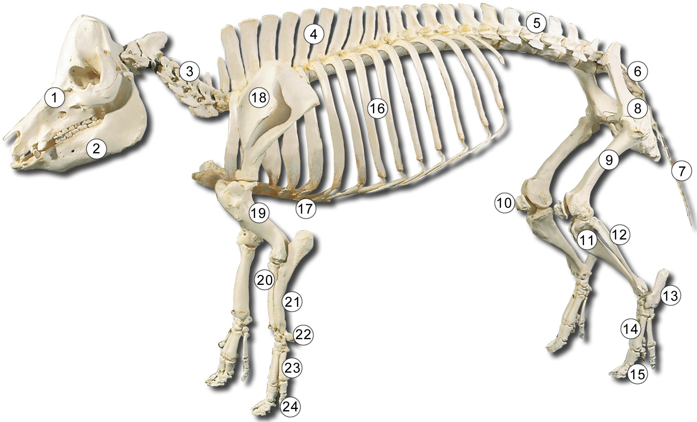

1. Skull 13. Tarsals

2. Mandible 14. Metatarsals

3. Cervical Vertebrae 15. Phalanges

4. Thoracic Vertebrae 16. Ribs

5. Lumbar Vertebrae 17. Sternum

6. Sacrum 18. Scalpula

7. Caudal Vertebrae 19. Humerus

8. Pelvis 20. Ulna

9. Femur 21. Radius

10. Patella 22. Carpals

11. Tibia 23.Metacarpals

12. Fibula 24. Phalanges